At Home in the Hive

Honey bee hives are busy places! At first glance, a honeycomb full of bees may look chaotic. What are all those bees doing?

A first step in biology is often to spend some time looking closely at nature. When you start to take in all the bustle of a living system, let your eyes linger, and your mind wander. What patterns do you notice over time? Do you see variations on any action or theme repeated in a way you can describe or define? There is no wrong answer. At this stage of a scientific investigation, all ideas are worth exploring!

Our scientists are always working to understand bees and their behaviors. This activity asks you to behave like a scientist and observe bees in their hive.

First, take a look at the large hive image (you can see it better if you download the image separately). What do you see? What questions do you have?

Next, look at and read about all the highlighted images below. These interactions can all be found in the whole hive image. Your task is now to see if you can find them or more examples of these behaviors.

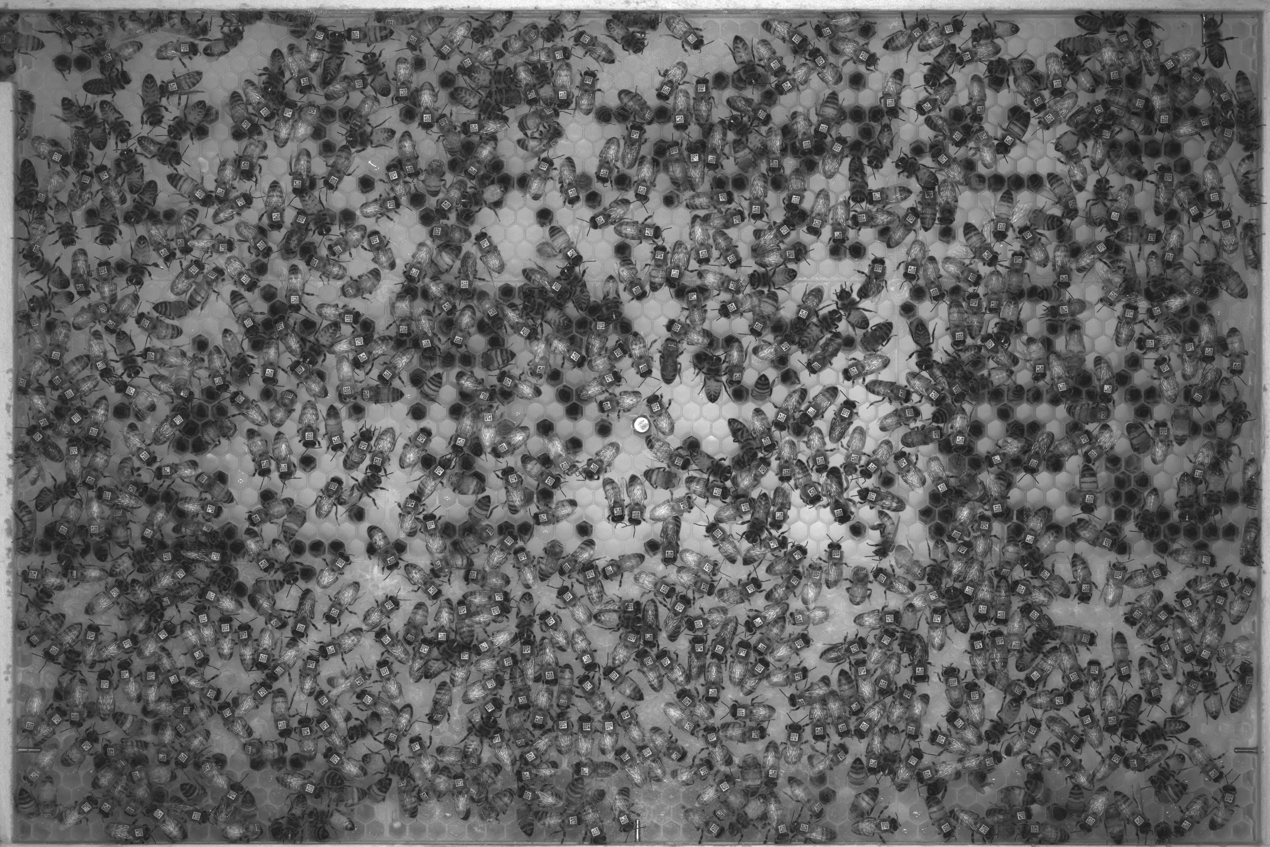
This picture shows a moment in the life of a honey bee colony. A honey bee hive can have as many as 60,000 bees, but in this very small colony there are just a few hundred spread out over a single piece of honey comb. Almost all are worker bees, female bees that are half or full sisters to each other, but one bee is their mother, the queen bee.
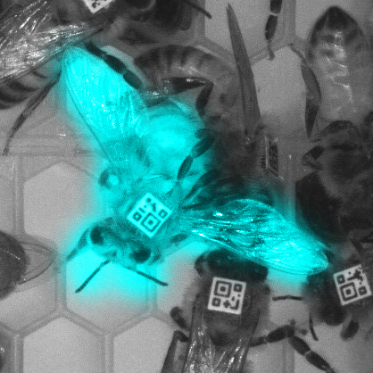

If you start to look closely at the bees in the hive, you may see many bees in the middle of certain motions or behaviors. For example, this worker bee has her wings spread wide, perhaps because she is fanning, quickly beating her wings to create a tiny breeze that will help cool the hive if it gets too warm.
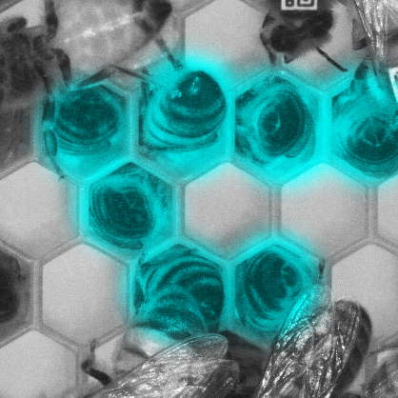

These bees, with their heads way down into the honey comb and their rears in the air may look a little silly, but they are likely doing one of two important tasks: getting a quick snack, or checking on an egg laid at the very bottom of a cell.
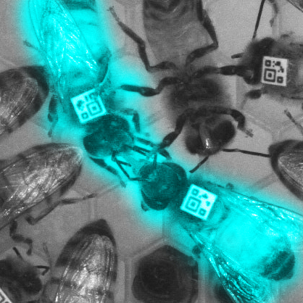

Bees don’t always get their snacks directly from the honeycomb. They also feed each other. When a hungry bee encounters a bee with a full honey stomach, the food-carrying bee will open her jaws and allow a droplet of honey or nectar to grow between them. The hungry bee will stick out her tongue and drink in the droplet, along with hormones and chemicals produced by her hive mate that send her messages about colony news.
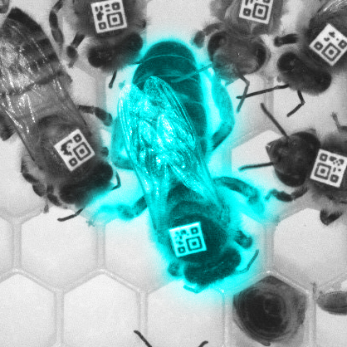

Queen bees don’t look as different from workers as you might expect. Still, if you look carefully, you can pick them out from the crowd. The queen is just a little bit bigger and has a longer abdomen that sticks out further beyond her wings and tapers to a point. The abdomen contains her egg-filled ovaries so the hive will continue to have plenty of worker bees. The long abdomen also allows her to scooch down into the very bottom of cells in the honeycomb and lay her eggs there. You may also notice that worker bees close to the queen turn their heads toward her as they attend to her needs, forming a “retinue.”

Do you like this activity? Tweet it at us, Gram it our way, or put it on Facebook! Tag us with #IGBIllinois

