Dissecting a Flower

Many flowers need to be pollinated in order to make new plants and to flourish. Flowers need to move pollen from the anther to the stigma, but since they can’t move, they recruit pollinators to help. The wind or pollinators like insects, bats or birds are the main ways pollen gets moved within a plant or between plants.
Flowers use colorful petals, nectar and pollen to attract animals to visit the flower. When an animal reaches into a flower for nectar some of the pollen from the anther will stick to its body and get transferred to the next flower it visits.
Today we are going to dissect a flower to learn more about the different parts of a flower that are important for pollination.
Go outside in your backyard and find a flower. Make sure it’s all right with your parents before you pick it. Now, take it inside and take your time removing the petals and taking apart the flower. See if you can find each different part and place them in the boxes below. Once you have your parts, do some research to find out what each part does.
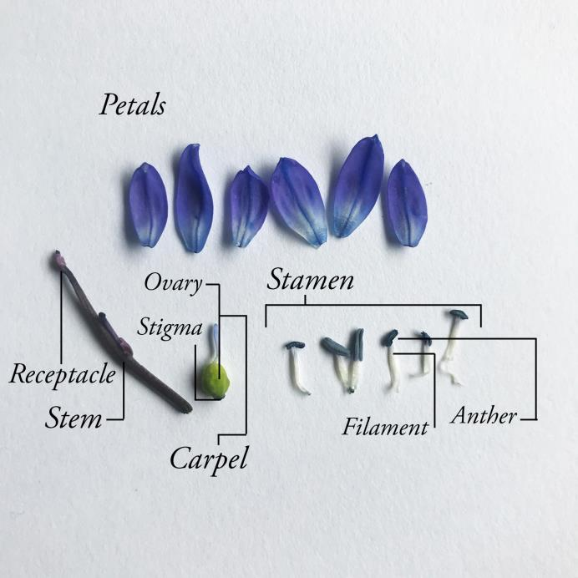

Stamen
Petal
Stem
Receptacle
Stigma
Ovary
Filament
Anther

Do you like this activity? Tweet it at us, Gram it our way, or put it on Facebook! Tag us with #IGBIllinois

