Wings of Things
Match the Creature with its wings!
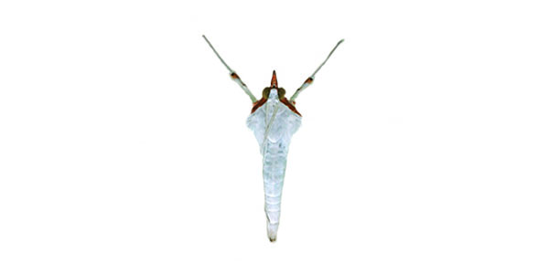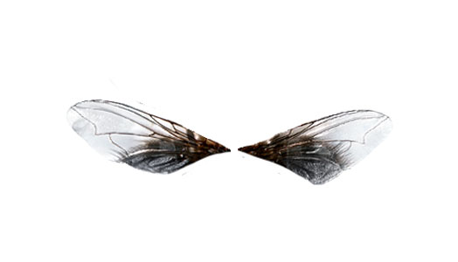
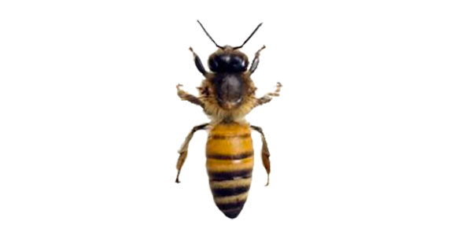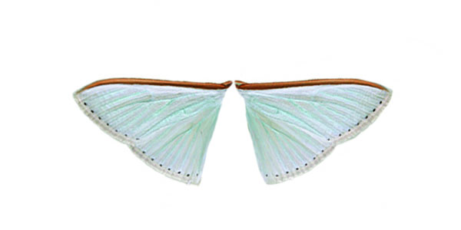
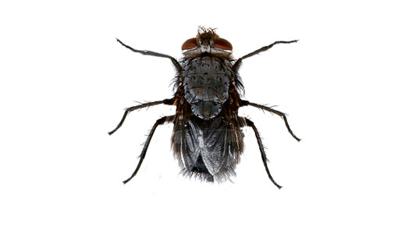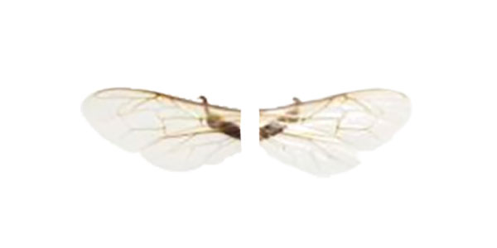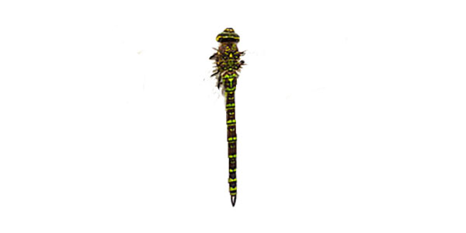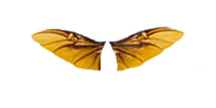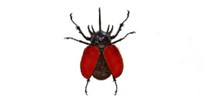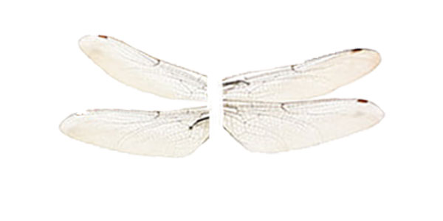
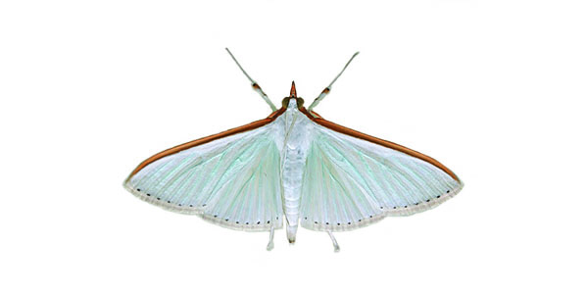
Insect Order: Lepidoptera - scale wings (moths, butterflies)
Moths wings, like those of other insects, are made of thin layers of chitin. They have two sets of wings, covered in what may look like powder but is actually tiny scales. These scales are made from modified hairs, that refract light and alter the apparent color of the wings (helpful for camouflage).
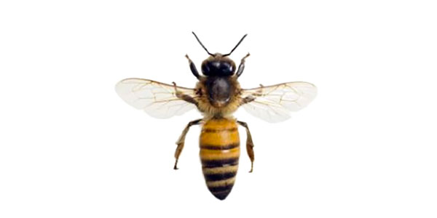
Insect Order: Hymenoptera - membrane wings (bees, wasps, ants)
Bees have two wings on each side held together by little hooks, called hamuli, so the wings flap in sync and act as one big wing. In addition to flying, bees use their wings for stationary fanning, to circulate air through the colony and modify the hive temperature.
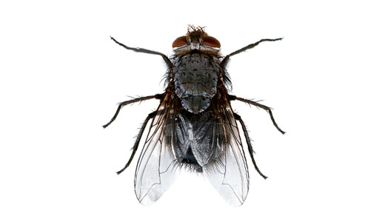
Insect Order: Diptera - two wings (“true” flies)
Houseflies only appear to have one set of wings, but they also have a tiny second set, called halters. These do not help generate lift, but provide stability during flight. Unlike bees, the two sets of wings move in opposite directions, rather than synchronously.

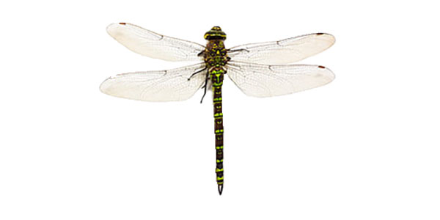
Insect Order: Odonata - unequal wings (dragonflies, damselflies)
Dragonflies beat their wings in an asymmetric rowing motion, instead of straight up-and-down like many other flying insects. Their two sets of wings are controlled by separate muscle groups, and the hindwings are always broader.

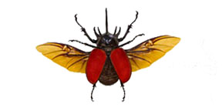
Insect Order: Coleoptera - sheath wings (beetles)
Beetles also technically have two sets of wings (this is starting to seem like a pattern). However, the forewings, called elytra, are hardened structures that mainly act to protect the body and the actual flying wings. The functional hindwings can be tucked underneath of the elytra for safety, and unfold outward when the beetle is ready to fly.

