Pollen Zebra Puzzle

Overview:
You find the pollen images Persephone told you about from past camps but realize the IDs have been scrambled by someone. The culprit decided to leave some clues behind for you – how thoughtful. Your mission is to correctly assign the 5 categories –genus, common name, shape, plant odor, and preferred habitat –to the right pollen image using the clues below. Good luck and remember, Persephone is counting on you!
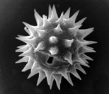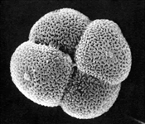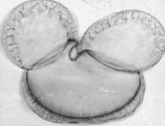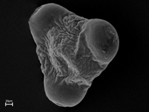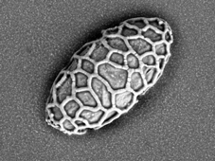
 | Pollen 1 | Pollen 2 | Pollen 3 | Pollen 4 | Pollen 5
Genus
Common Name
Shape
Plant Odor
Preferred Habitat

Key Information

Genus: Helianthus, Lilium, Oenothera, Picea, Typha
Common Name: Cattail, Lily, Primrose, Spruce, Sunflower
Shape: Clustered group of four, Mickey Mouse head, Round and spiky, Triangle with rounded edges, Wrinkly oval
Plant Odor: None, Cloves, Honey, Lemony, Piney
Preferred Habitat: Forests, Marshes, Meadows, Prairies, Valleys

Clues:
Lilium is on one of the ends
Primrose smells like lemon
Mickey Mouse is on the right side of the Cattail
The Sunflower is left of Typha
Picea prefers streamsides in mountain valleys
Cattails are found in marshes
The Triangle shape is between the Piney scent and the Lily, in that order
Typha has no scent
Helianthus pollen is spiky
The Lemon scent is just left of Lilium
Spruce is between Typha and Primrose, in that order
The Clove scent is on the right side of the Meadow dweller
Prairies sometimes smell of Honey
Oenothera is on the right side of Spruce
Pollen Zebra Puzzle Key

Overview:
You find the pollen images Persephone told you about from past camps but realize the IDs have been scrambled by someone. The culprit decided to leave some clues behind for you – how thoughtful. Your mission is to correctly assign the 5 categories –genus, common name, shape, plant odor, and preferred habitat –to the right pollen image using the clues below. Good luck and remember, Persephone is counting on you!
 | Pollen 1 | Pollen 2 | Pollen 3 | Pollen 4 | Pollen 5
Genus | Helianthus | Typha | Picea | Oenothera | Lilium
Common Name | Sunflower | Cattail | Spruce | Primrose | Lily
Shape | Round and spiky | Clustered group of four | Mickey Mouse head | Triangle with rounded edges | Wrinkly oval
Plant Odor | Honey | None | Piney | Lemon | Cloves
Preferred Habitat | Prairies | Marshes | Valleys | Meadow | Forests

Key Information

Genus: Helianthus, Lilium, Oenothera, Picea, Typha
Common Name: Cattail, Lily, Primrose, Spruce, Sunflower
Shape: Clustered group of four, Mickey Mouse head, Round and spiky, Triangle with rounded edges, Wrinkly oval
Plant Odor: None, Cloves, Honey, Lemony, Piney
Preferred Habitat: Forests, Marshes, Meadows, Prairies, Valleys

Clues:
Lilium is on one of the ends
Primrose smells like lemon
Mickey Mouse is on the right side of the Cattail
The Sunflower is left of Typha
Picea prefers streamsides in mountain valleys
Cattails are found in marshes
The Triangle shape is between the Piney scent and the Lily, in that order
Typha has no scent
Helianthus pollen is spiky
The Lemon scent is just left of Lilium
Spruce is between Typha and Primrose, in that order
The Clove scent is on the right side of the Meadow dweller
Prairies sometimes smell of Honey
Oenothera is on the right side of Spruce

